**Lab sheet 11 - Deep Learning**

1. **Neural Network Language Model**

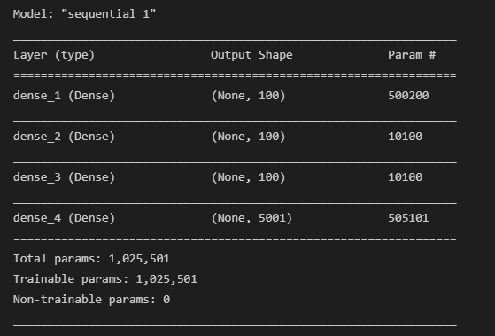

Model fitting

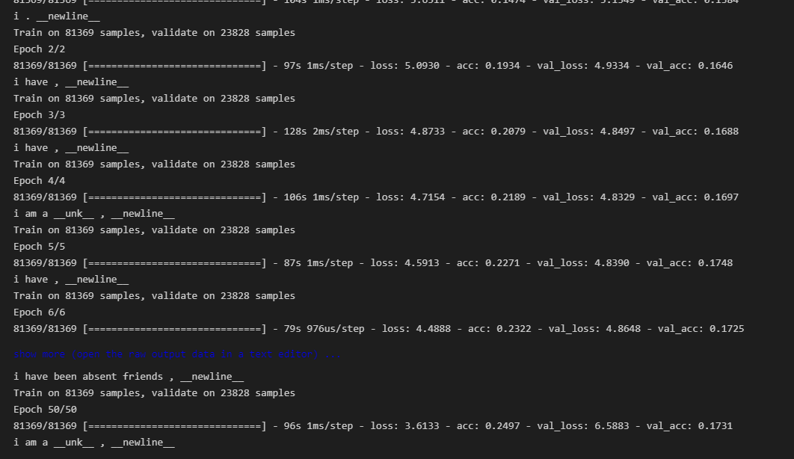

**Bigram model**

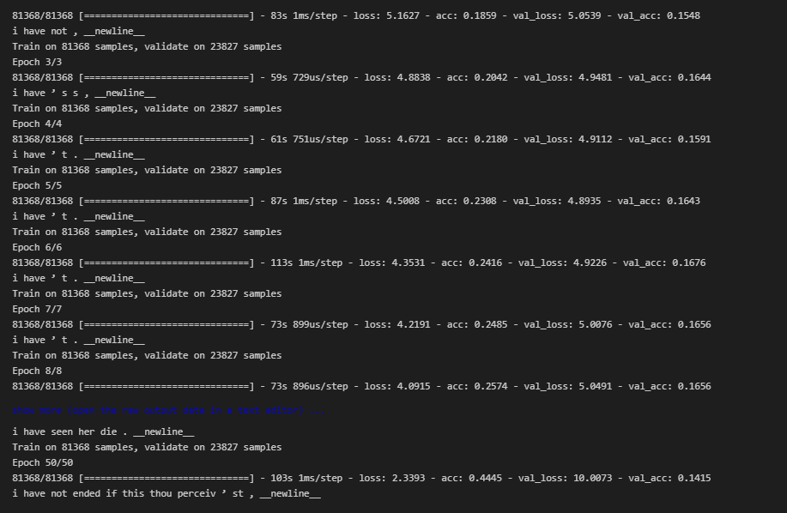

**Trigram model**

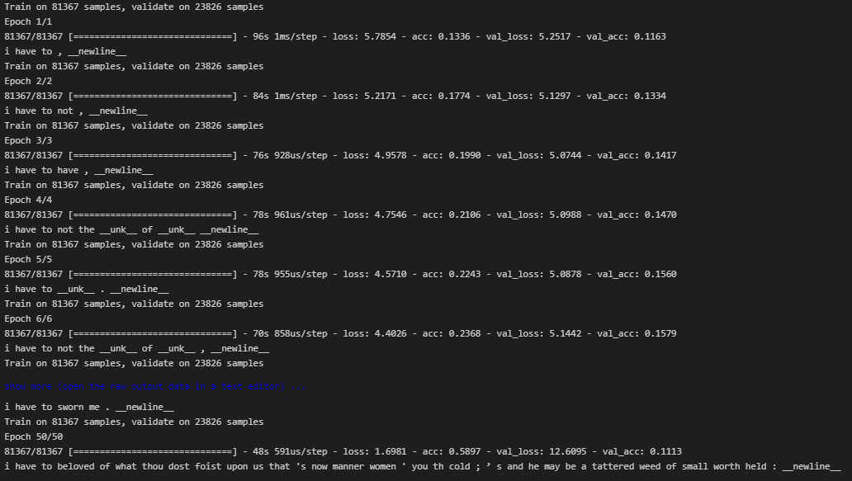

1. **Sentiment Classification using Neural Network**

Model architecture

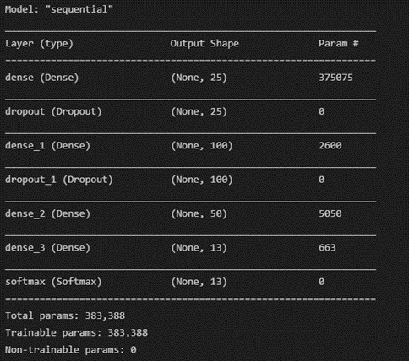

Test accuracy



Confusion matrix

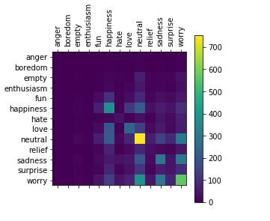

1. **Per timestep prediction using Neural Network – POS tagging**

Vocabulary building

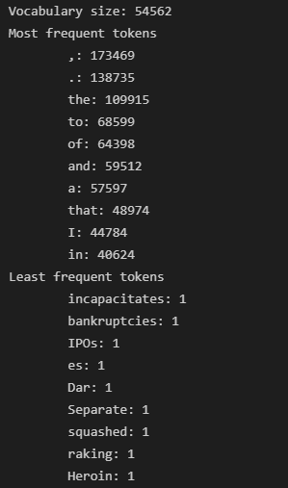

Model Definition

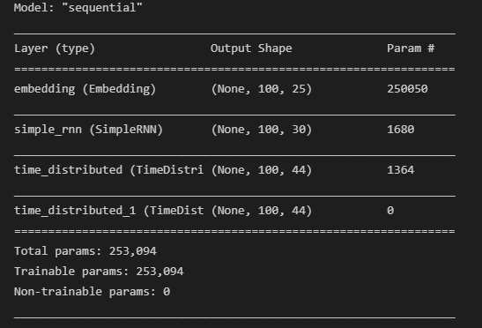

Test set accuracy

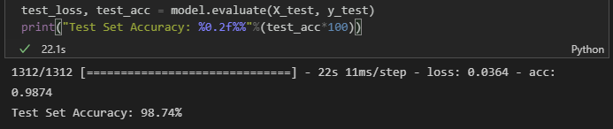

1. **Pre trained embedding**

Pre trained vectors

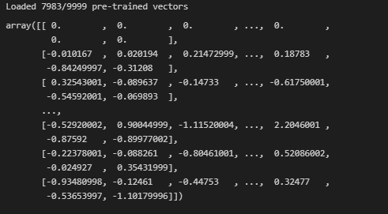

Training and testing accurcy

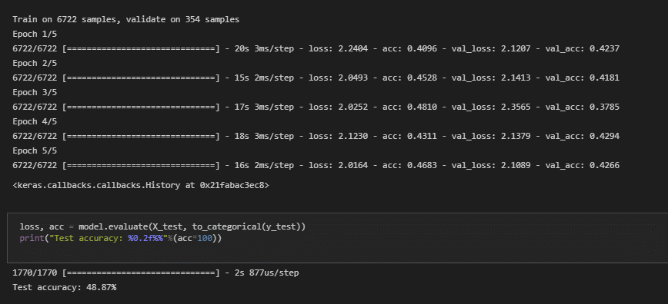

1. **Recurrent Neural Network**

Data Loading

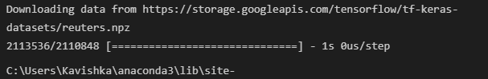

Data preparing

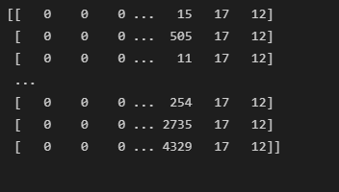

Simple RNN

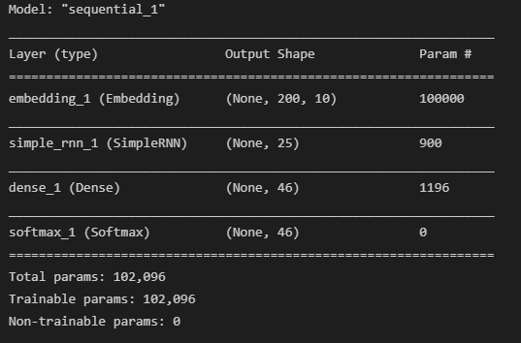

Result

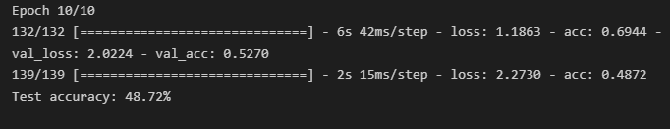

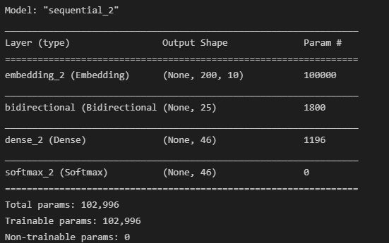Bidirectional RNN

Result

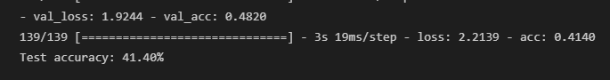

Simple RNN with averaging

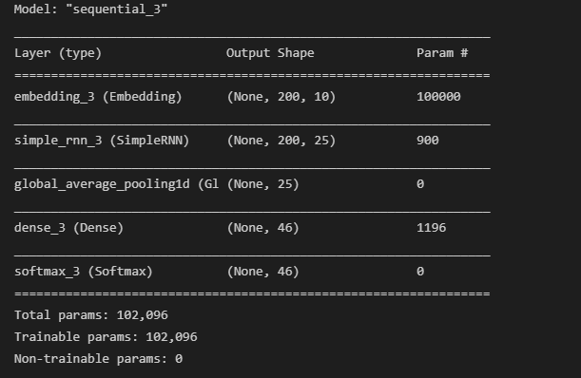

Result

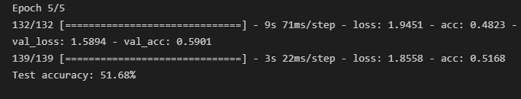

Multilayer Bidirectional RNN

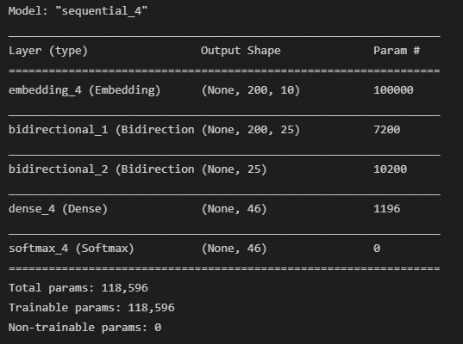

Result

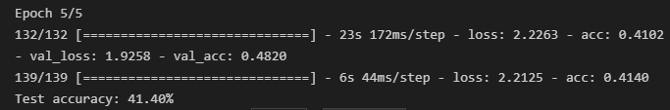

1. **Reuters News Classification**

Data loading



Dense NN model



Vanilla RNN

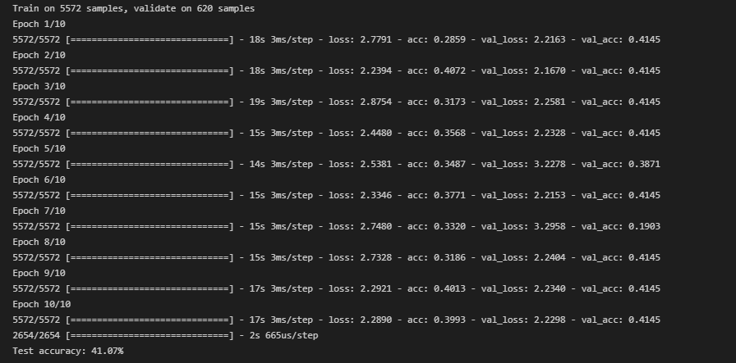

Bidirectional RNN

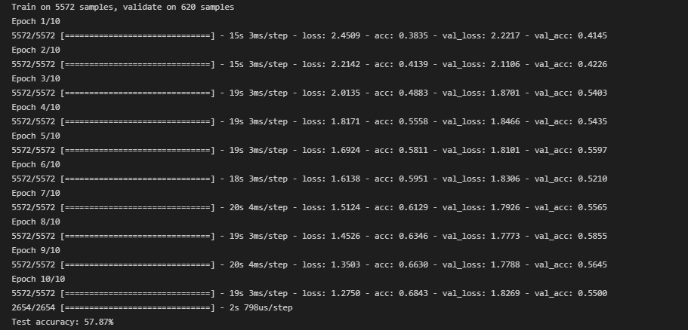

Multilayer Bidirectional RNN

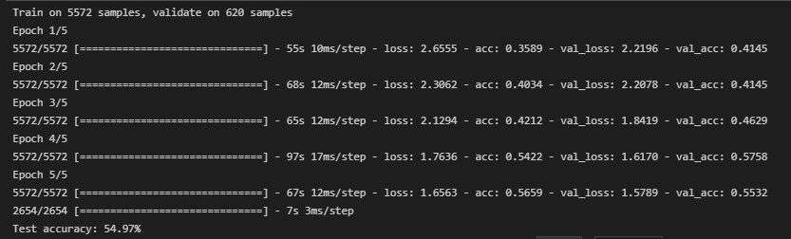

1. **Text-Generation-with-LSTM**

